Office Use Only:
Applicant Hired?
YES ( ) NO ( )
Date Employed:

APPLICATION FOR QUALIFICATION
Eliason Ranch Trucking LLC
1855 W MAIN ST * PO BOX 250 TREMONTON, UT 84337
Phone: 435-230-8265 Email: mike@eliason.team
The purpose of this application is to determine whether the applicant is qualified to
Operate motor carrier equipment according to the requirments of the Federal Motor Carrier
Safety Regulations and the Company named above.

INSTRUCTIONS TO APPLICANT: Driver must complete application personally. Original must be turned into office for hiring purposes. Please answer all questions. If the answer to any question is “No” or “None”, do not leave the item blank, but write “No” or “None”. Also please write legible! This is important!
*The Age Discrimination of Employment Act of 1967 prohibits discrimination based on age with respect to individuals who are at least 40 but less than 70 years of age.

Date _________________________________ Check One: Contractor Driver

PERSONAL INFORMATION
Name: Last First Middle |  |  |  |  |  |  |  | Email Address
Home Number: |  | Cell Number: |  |  |  |  | Emergency Contact: |  |  |  |  | Phone Number:
Age | Date of Birth |  | Social Security |  |  |  |  |  | Physical Exam Taken |  |  |  | Medical Card Expires
Drivers License Number |  |  |  | State of Drivers License |  | Endorsements |  |  |  |  | Drivers License Expires
CDL Issued: |  |  |  |  | Years Local Experience |  |  |  |  | Years Over the Road Experience

ADDRESS HISTORY Current Address and Previous Addresses
Current Address:
Street Address City State Zip | From To
Street Address City State Zip | From To
Street Address City State Zip | From To
Street Address City State Zip | From To

EDUCATION HISTORY
Please circle the highest grade completed: Grade School: 1 2 3 4 5 6 7 8 9 10 11 12

College: 1 2 3 4 Post Graduate: 1 2 3 4

EMPLOYMENT HISTORY
Give a Complete Record of all employment for the past THREE years, including any unemployment of self-employment, and all commercial driving experience for the past TEN years. Begin with your most recent history.
Please make copies of this page if you need more to reach 10 YEARS!
Previous Employer: | MC # | DOT #
From: To: | Company Name: | Supervisor’s Name:
Mo/Yr Mo/Yr
Reason for Leaving: | Co Address: | Co Phone #: Co Fax #:
Job Duty Description:
Where you subject to the FMCSRs* while employed here? Yes No
Was your job designated as a safety-sensitive function in any DOT-Regulated mode subject to the drug and alcohol testing requirements of 49 CFR Part 40? Yes No

Previous Employer: | MC # | DOT #
From: To: | Company Name: | Supervisor’s Name:
Mo/Yr Mo/Yr
Reason for Leaving: | Co Address: | Co Phone #: Co Fax #:
Job Duty Description:
Where you subject to the FMCSRs* while employed here? Yes No
Was your job designated as a safety-sensitive function in any DOT-Regulated mode subject to the drug and alcohol testing requirements of 49 CFR Part 40? Yes No

Previous Employer: | MC # | DOT #
From: To: | Company Name: | Supervisor’s Name:
Mo/Yr Mo/Yr
Reason for Leaving: | Co Address: | Co Phone #: Co Fax #:
Job Duty Description:
Where you subject to the FMCSRs* while employed here? Yes No
Was your job designated as a safety-sensitive function in any DOT-Regulated mode subject to the drug and alcohol testing requirements of 49 CFR Part 40? Yes No

Previous Employer: | MC # | DOT #
From: To: | Company Name: | Supervisor’s Name:
Mo/Yr Mo/Yr
Reason for Leaving: | Co Address: | Co Phone #: Co Fax #:
Job Duty Description:
Where you subject to the FMCSRs* while employed here? Yes No
Was your job designated as a safety-sensitive function in any DOT-Regulated mode subject to the drug and alcohol testing requirements of 49 CFR Part 40? Yes No

Explain any gaps in employment:

List all states or foreign countries operated in for the last five years:

DRIVING EXPERIENCE
Class of Equipment | Dates  From To |  | Type of Equipment  (Van, Tank, Flat, etc.) | Approximate Total Miles

Straight Truck

Tractor and Semi-trailer

Tractor –two trailers

Reefer Experience
ACCIDENT RECORD FOR THE PAST THREE YEARS (attach a sheet if more space is needed)
Date of Accident | Nature & Details of Accidents  DOT or NON DOT  (Head on, rear end, upset, etc.) | Location of Accident  # of Vehicles Towed  Preventable | # of People Injured | # of Fatalities
TRAFFIC CONVICTIONS AND FORFEITURES FOR THE LAST THREE YEARS (All convictions, other than parking violations)
Date | Location | Vehicle Type |  | Charge | Penalty
 |  | CMV | Non CMV
 |  | CMV | Non CMV
 |  | CMV | Non CMV
DRIVER’S LICENSE ( List each driver’s license held in the past three years)
State | License # | Type | Endorsements | Expiration Date
DRIVER’S SAFETY (List all Awards, Violation, Out of Service, Training Courses, etc. for the last year)
 | Date | Award, Violation, Out of Service | Comments
A. Have you ever been denied a license, permit or privilege to operate a motor vehicle? . . . . . YES ( ) NO ( )
B. Has any license, permit or privilege ever been suspended or revoked? . . . . . . . . . . YES ( ) NO ( )
C. Have you ever been convicted of a felony? . . . . . . . . . . . . . . . . . . YES ( ) NO ( )
D. Have you ever tested positive or refused a DOT drug or alcohol pre-employment test within the past two years
from an employer who did not hire you? . . . . . . . . . . . . . . . . . YES ( ) NO ( )

If the answer to A, B, C or D is “YES”, give details:

PERSONAL REFERENCES
List three persons for reference (other than family members) who have knowledge of your safety habits.
Name: | Phone Number: | Address: | How they know your habits:

TO BE READ AND SIGNED BY APPLICANT

It is agreed and understood that any misrepresentation given on this application for qualification shall be considered an act of dishonesty.
I give the motor carrier and its agents or representatives the right to investigate all references and to secure additional information about my employment background. I herby release from all liability for damages the motor carrier and its agents or representatives for seeking such information and all other persons, corporations or organizations for furnishing such information.
I agree to furnish such additional information and complete such examinations as may be required to complete my employment file.
It is agreed and understood that this application for qualification in no way obligates the motor carrier to employ me.
It is agreed and understood that if qualified to operate motor carrier equipment, I may be on a probationary period, during which I may be disqualified without recourse.

“I certify that this application was completed by me, and that all entries on it and information in it are true and complete to the best of my knowledge.”

Applicant’s Signature Date

Request for Driver’s Safety Performance History
Information from DOT Regulated Previous Employer(s)

Carrier Name | Contact | Phone | Confidential Fax | Address
Eliason Ranch Trucking | Mike Martin  mike@eliason.team | 435-230-8265 | 435-257-0181 | PO Box 250 Tremonton, UT 84337
I hereby authorize this company to release all records of employment, including assessments of my job performance, ability and fitness, including dates of any and all alcohol or drug tests. Those confirmed results and/or my refusal to submit to any alcohol or drug tests and any rehabilitation completion under direction of (SAP/MRO) to each and every company (or their authorized agents) which may request such information in connection with my application for employment with said company. I hereby release this company, and its employees, officers, directors, and agents from any and all liability of any type as a result of providing information to the above-mentioned person and/or company.

Applicant Name Printed | SSN | DOB |  | Applicants Signature |  | Date
Dates of Employment  From  Month/Year | To  Month/Year

Previous Employer Name | Company Contact | Company Phone |  | Company Fax
Company Mailing Address | Dates of Employment From  Month/Year |  | Dates of Employment To  Month/Year

Past Employer to Complete DRUG & ALCOHOL INFORMATION
SECTION 1 –Please provide the following drug and alcohol information as required by FMCSR Part 391.23 & 40.25.
If no drug and alcohol information is available on above-named applicant check here.If the driver was not subject to Department of Transportation testing requirements, please Reason not Subject:
- YES ( ) NO ( ) Has this person had any alcohol test with a result of 0.04 or higher alcohol concentration? .
- YES ( ) NO ( ) Has this person tested positive or adulterated or substituted a test specimen for controlled substances?
- YES ( ) NO ( ) Has this person refused to submit to a post accident, random, reasonable suspicion, follow-up alcohol or controlled substance test?
- YES ( ) NO ( ) Any other violations of DOT agency drug and alcohol testing regulations (Part 382 or part 40)?
- YES ( ) NO ( ) If this driver did successfully complete a SAP rehabilitation referral and remained in your employ, did he/she have any subsequent violations for: an alcohol test result of 0.04 or greater, a verified positive drug test or a refusal to test (including a verified adulterated/substituted drug test result)?
- If YES to any of the above questions, please provide documentation of successful completion of a SAP evaluation, prescribed treatment and return-to-duty requirements (including follow-up tests) if they remained in your employ. *
*If this information is not available from the previous employer, you as a prospective employer must get this information from the driver/applicant.
Drug and alcohol information needs to be kept in a separate personnel and/or confidential file.

Past Employer to Complete ACCIDENT INFORMATION
SECTION 2 – Please provide the following information on the driver/applicant;
Was the applicant involved in any accidents? If so, include dates and brief explanation:

DOT/Non-DOT Recordable? | Was the accident Preventable?
Was the driver responsible for the accident?
Other details of Accident:

Past Employer to Complete SAFETY/ADMINISTRATIVE INFORMATION
SECTION 3 – Please provide the following information on the driver/applicant;

He/She was employed for you as a: from / / to / /
What was the applicants’ position with your company? Was he/she a:
Company Driver |  | Contract Driver |  | Contractor |  | Other

Did the applicant drive a motor vehicle for your company? If employed as a driver, what type of equipment did he/she operate.
Straight Trucks |  | Tractor/Trailer |  | Doubles |  | Triples |  | Other
Flat Bed |  | Belly Dump |  | Van |  | Reefer |  | Other

Was the driver ever placed out of service for hours of service violations? If yes, please explain.

Was the applicants’ general conduct satisfactory?

 | Discharged |  | Laid Off |  | Resigned
Reason for leaving your company:

Would you re-hire him/her? If not, why? Additional Comments:

 | Yes Re-hire |  | No – would not re-hire |  | Upon Review

General area traveled and commodities transported.

What kinds of work did the applicant do?

Was the applicant a safe driver?

Previous Employer Representative Supplying Information:

Printed Name Signature Title Date

CONTROLLED SUSTANCE & ALCOHOL TESTING
INFORMATION ACKNOWLEDGEMENT/CONSENT FORM

As a condition of employment with Eliason Ranch Trucking, LLC, Commercial Motor Vehicle (CMV) Driver Applicants must submit to a pre-employment controlled substances test as required by the Federal Motor Carrier Safety Regulations (FMCSR) Section 382.301. A motor carrier must receive verified negative test results for the applicant driver for the applicant to be eligible for employment.

If you are hired, you will be subject to laws requiring additional controlled substances and alcohol testing on you under numerous situations including, but not limited to, the following:

Post-Accident – Section 382.303 | Random – Section 382.305 | Reasonable Suspicion – Section 382.307
Return to Duty – Section 382.309 |  | Follow-up – Section 382.311

A driver, who tests positive for a controlled substance and/or alcohol test, will be immediately removed from a safety-sensitive position as required by Part 382 of the MFCSR. Federal law prohibits a driver from returning to a safety-sensitive position for any motor carrier until and unless the driver completes the Substance Abuse Professionals (SAP) evaluation, referral and educational/treatment process, as described in FMCSR Part 40, Subpart O.

The following is a referral list of Substance Abuse Professionals:
NAME | Michele Myers  SAPAA | Marlin Andrus  EAPA | Maria G. Jensen  ASAP
ADDRESS  EMAIL | 4155 Harrison Blvd., Ste. 200  Ogden, UT 84403  mmyers@smartfella.com | 2100 South State Street  Salt Lake City, UT  South Jordan, UT  Midvale, UT  Mandrus528@aol.com | 2975 Overland Ave  Burley, ID 83318  options@pmt.org
PHONE # | (801) 510-4790 | (801) 253-3169 | (208) 878-2600

All Controlled substances and alcohol testing will be conducted in accordance with Parts 40 and 382 of the FMCSR.

I have read the above controlled substances and alcohol testing requirements and understand them. I acknowledge the receipt of the referral list of Substance Abuse Professionals.

Applicant Signature Employer Signature Date

Original to be kept on file - Copy to be given to applicant.
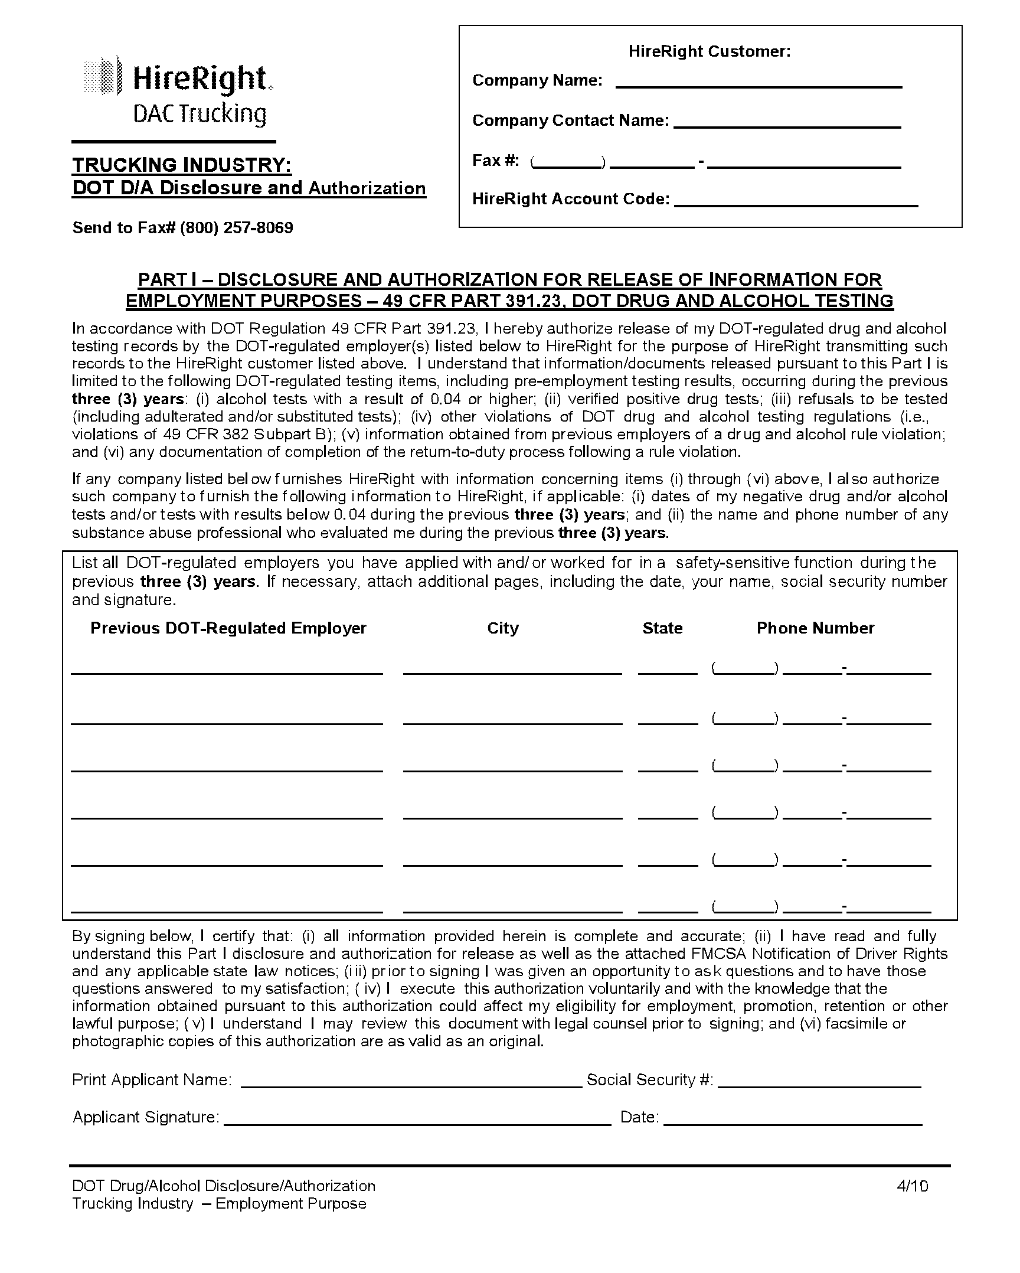
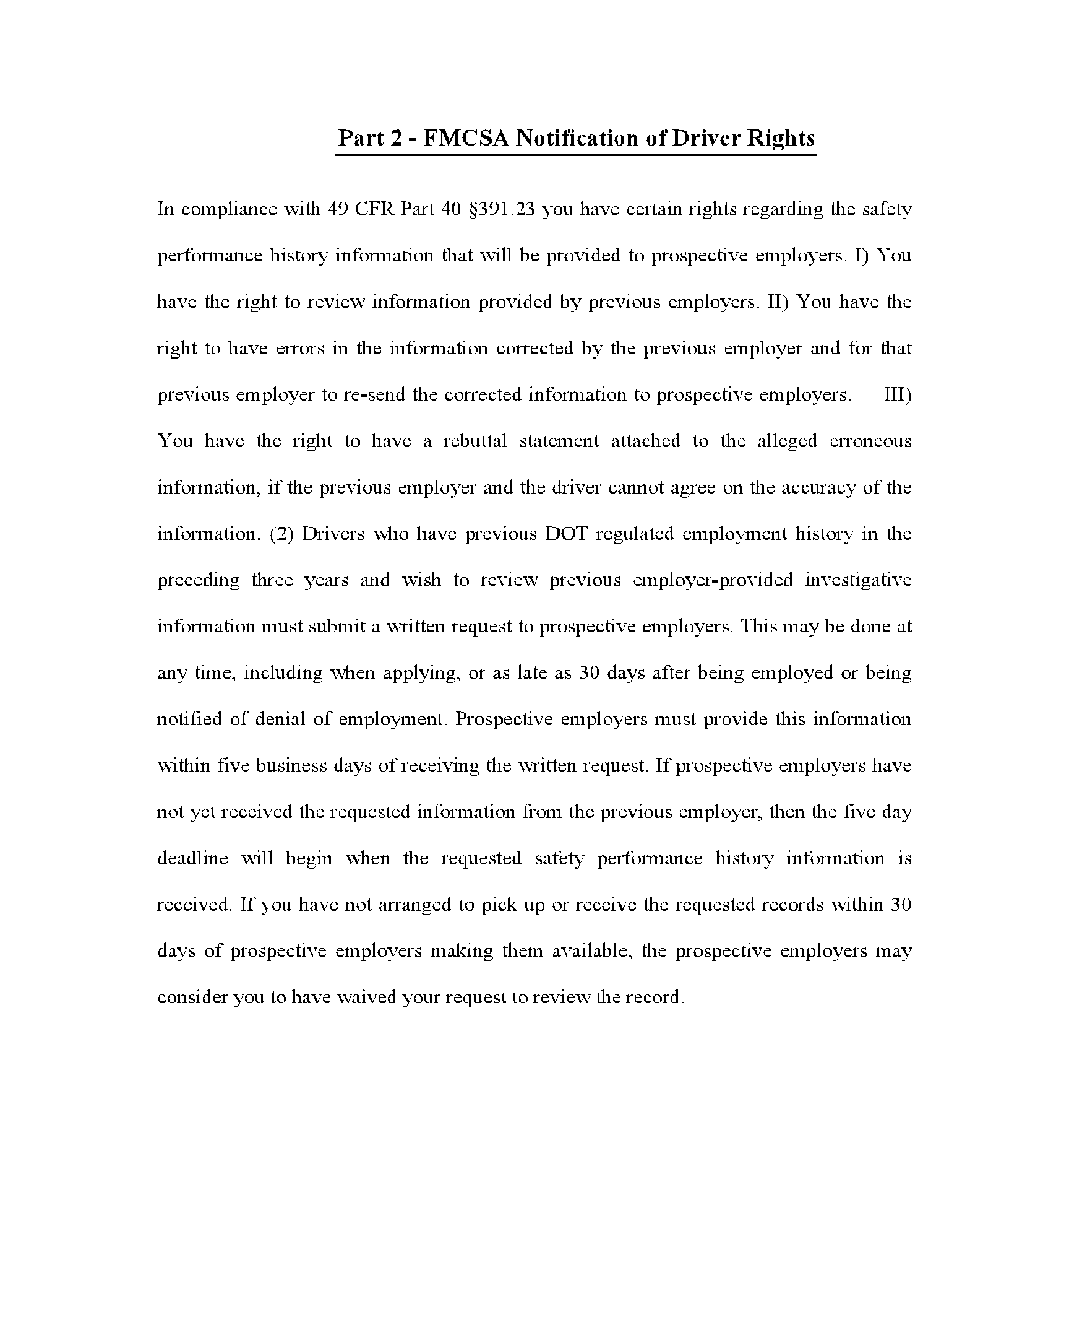
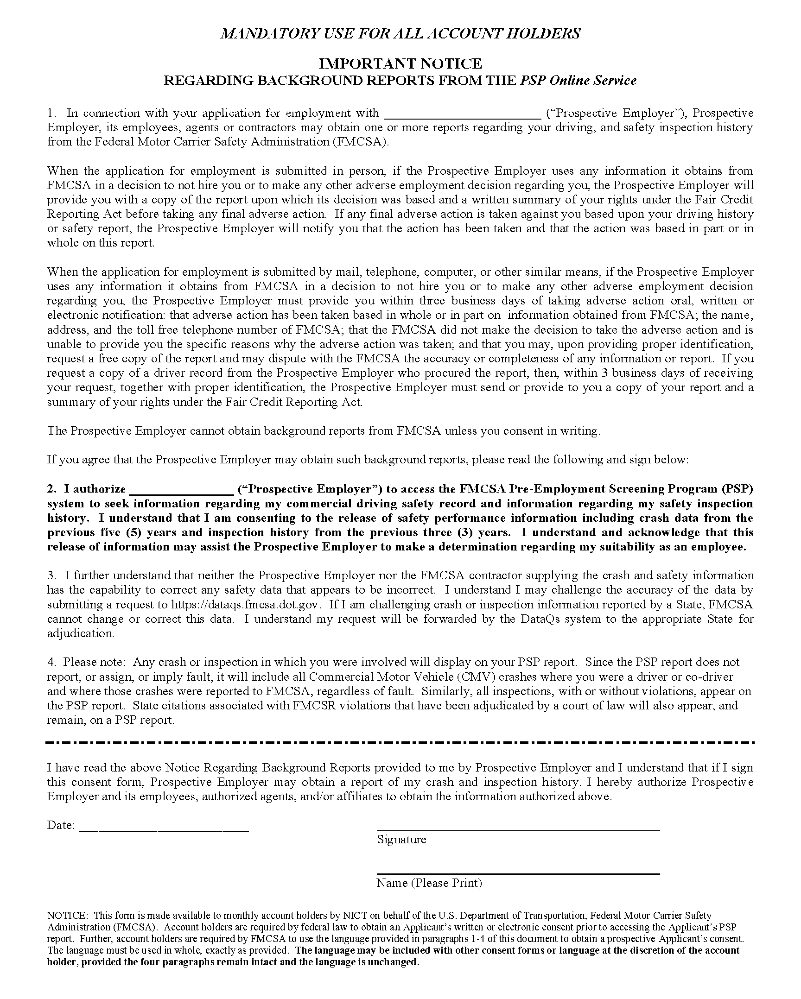
REQUEST FOR MVR BASED ON PERMISSIBLE USE #13 OF THE DPPA

This form shall be used by persons making requests for a driver record (MVR – Motor Vehicle Report) under U.C.A. 53-3-104. The form shall be completed by any requester who requires the written consent of the person to whom the information pertains. An MVR shall be released by the division only to qualifying requesters pursuant to >permissible uses= articulated in the federal Driver Privacy Protection Act (DPPA).

PERSON REQUESTING THE MVR
Name of the requester Katie Noorda or Mike Martin 435-257-4500
Eliason Ranch Trucking

Certification Statement: I certify under penalty of law that I am entitled to personal information from the requested driver record. I am aware that there are criminal and civil penalties for knowingly obtaining, disclosing, or using the personal information for a purpose not permitted under DPPA (18 U.S.C. “2721-2724).

PERSON TO WHOM THE MVR PERTAINS
The requester listed above requests access to driver record(s), including personal information as defined in 18 U.S.C. “2721-2724, concerning the following person:
First Name |  | Middle |  |  | Last Name |  | Maiden Name
Date of Birth | Drivers License Number |  | State of License |  |  | Social Security Number
Physical Address: |  |  |  | Mailing Address:

I am the individual to whom the MVR pertains and am the subject of the record. I grand permission for the above requester to receive copies of my driver license record (MVR) Reports.

Drivers Signature
DRIVERS RIGHTS PERTAINING TO RELEASE OF
DRIVER INFORMATION UNDER REGULATIONS 391.23

Motor carriers have the responsibility to make the following investigations and inquiries with respect to each driver employed, other than a person who has been a regularly employed driver of the motor carrier for a continuous period which began before January 1, 1971.
(a)(1) An inquiry into the driver’s driving record during the preceding three years to the appropriate agency of every state in which the driver held a motor vehicle operator’s license or permit during those three years:
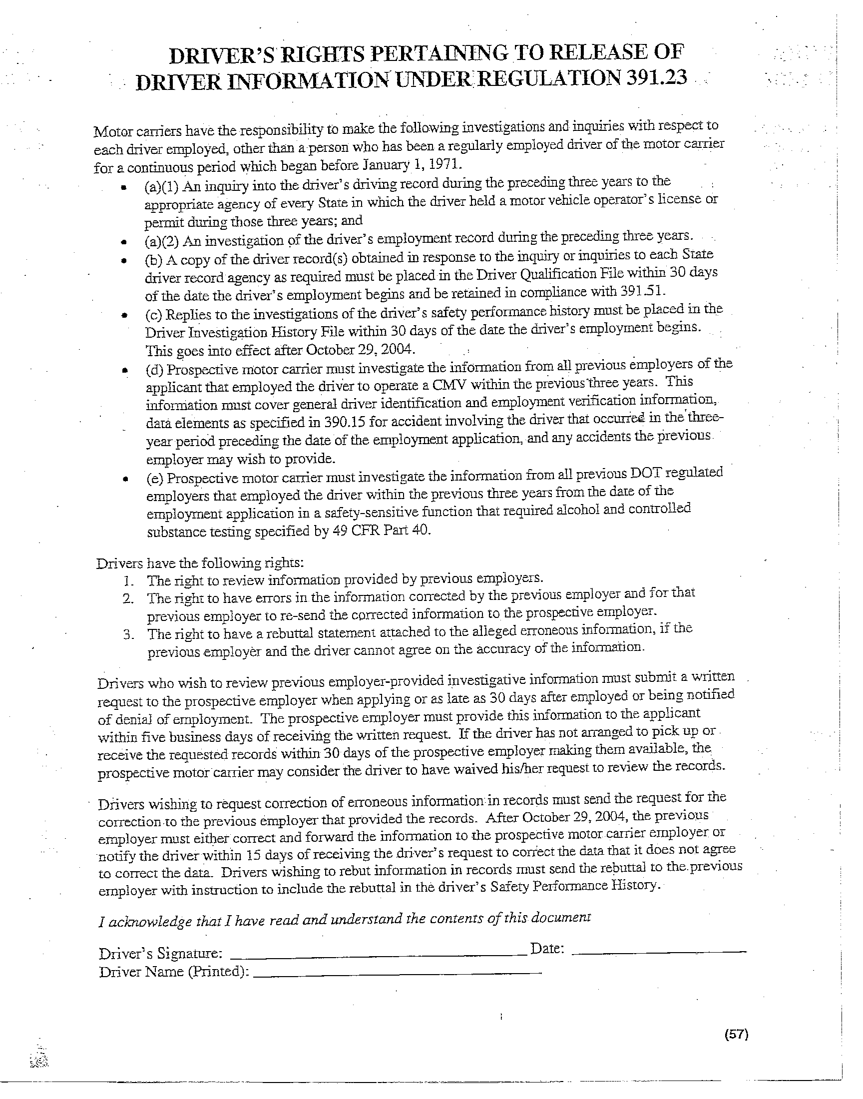
ELIASON RANCH TRUCKING, LLC
PO BOX 250 Tremonton, UT 84337
1855 West Main Tremonton, UT 84337
PHONE 800-760-8135 FAX 435-257-0181

Job Requirements

Commercial Motor Vehicle Driver Over-the-Road
This job description is only intended to be a general guideline,
and is not intended to include every rule, regulation, or company policy.

Principal Duties and Responsibility
Drives tractor and 53-foot reefer combination transporting safely and efficiently all assigned shipments. | Over the road lanes: including but not limited to the Western states, North Carolina, and Texas.
Logs: Always maintain a current log. Always know how many hours you have available, so you are aware of any concerns and limitations. Logs are due 6 days after delivery with trip envelope. | Commodities: Ice-cream, produce, groceries, potatoes, etc.
Communication: Please make a check call every day. Keep in touch with dispatch regarding all pick-ups and deliveries. Notify dispatch of any discrepancies on load. Notify dispatch of all lumper costs before leaving the dock. Please be courteous, patient, and respectful at the docks. Your actions and attitude reflect on the entire company. If you feel you are being treated unfair call into dispatch to correct the matter. | Safety: Comply with all regulations, laws, rules, and company policies and procedures while performing job duties. Any and all accidents, incidents, traffic violations, and/or arrests must be reported immediately to the proper company representative. Report all road hazards observed enroute.
Dispatch: Makes delivery or pick-up freight timely, obtaining signed receipts for bill of ladings and any lumpers. Notify dispatch of all lumper costs before leaving the dock. | Equipment Maintenance: Maintain equipment pre & post trip inspections as required by company policy, state, federal, and local laws to ensure the vehicle is in safe operating condition.
Trip Envelopes: Please fill out trip envelope completely. All documents inside the envelope need to be documented on the front. Please specify all states, miles, fuel, expenses and cash. Make sure miles match from beginning to end. | Safety: All paperwork to be turned in within 6 days of delivery. Including but not limited to bill of ladings, lumper receipts, logs, fuel receipts, maintenance receipts, and reporting miles.
Maintenance: All receipts for maintenance and fuel are to be turned in with each trip for reimbursement. | Payroll: All paperwork is due before payroll to eliminate any errors.

This is just a reminder to keep things running smooth. If you have any questions or concerns, we ask that you bring them to our attention as soon as possible so they don’t balloon into something big or before it is too late to correct. We want to thank you for all your efforts and hard work.

Work Environment
Will spend time outside at times during inclement weather conditions. Duties including but not limited to putting chains on tires, maintenance checks on truck and trailer. | Subject to irregular work schedules, long trips, tight delivery schedules, and delays enroute on crowded streets and highways in all kinds of weather and during day or night.
Will spend a large percentage of time in the commercial motor vehicle over-the-road in different states across the United States. | May be exposed to heat, cold, dust, noise, and other irritants.

Knowledge and Skills Required
Must have two years verifiable over the road experience operating a commercial motor vehicle. | Must be at least 23 years of age.
Must possess and maintain a valid Commercial Driver’s License in the state of residence with the proper endorsements. | Must be physically qualified to operate a commercial motor vehicle as required by Title 49, CFR. 301.41 and company policy.
Must possess a good working knowledge and operating ability of a tractor/trailer combination unit; the knowledge and ability to perform minor repairs on the road; and the knowledge and ability to maintain equipment in a good condition consistent with company policy and local, state, and federal laws. | Must have the ability to read, write, and speak the English language sufficiently to complete all paperwork requirements established by company policy, and various laws and regulations.

Physical Demands
Must be able to perform occasional squatting, stooping, crouching, crawling, bending, twisting, climbing, reaching, lifting, and balancing as required to inspect equipment, to enter and exit vehicles, and to affect loading and/or unloading of commodities transported. | Must have the physical and mental ability to sit, stand, and remain alert while driving or while otherwise on duty for long periods of time up to 11 hours driving without rest or relief.
Must be able to walk, bend, reach, stoop, squat, kneel, crawl, or climb under trailers to inspect, affect repairs, open and/or replace domes, valves, vents, or other equipment necessary for safe and efficient operation of the trailer. | Must be able to enter and exit the vehicle’s cab 10 or more times a day with entry and exit achieved with the assistance of various configurations of steps and above shoulder-handholds.
Must be able to lift and connect various hoses, fittings, and other equipment weighting up to or in excess of 50 pounds. | Must be able to hook and unhook trailers from the tractor including cranking lever used to raise and lower landing gear on trailers.
Must be able to lift and carry items weighting up to 50 pounds a distance of up to 150 feet. | Must be able to grasp, fit and properly use had tools as required.
Must have mechanical aptitude. | Must have good working habits.
Report all accidents, spills, or property damage, regardless of extent of damage or injury, immediately to the proper company representative. | Must be able to follow written and verbal instructions in the English language.
Report the condition of the equipment used at the end of each trip. | Contact dispatch as required.
Make repairs to tractors and trailers as necessary for safe operation. | Keep vehicle(s) assigned in clean condition.
Follow company guidelines pertaining to acceptable conduct when dealing with supervisors, shop personnel, drivers, and customers. | Complete and maintain records of service, maintenance, costs, and inspections.
Practice good personal hygiene projecting an image of quality and professionalism at all times.

Report to
Derek - Load Coordinator  *Mid-west & East Coast inbound  435-237-9380  Derek@Eliason.Team | *Requesting time off  *Low on hours and cannot meet scheduled picks or deliveries  *Violation, Ticket, Accident, or Incident, or Concerns notify immediately (also notify Shane or Kate)
Jared - Load Coordinator  *AZ,CO & West Coast inbound  435-230-8413  Jared@Eliason.Team | *When going to be late for pick or deliveries  *Discrepancies in load (case counts / temps / pick & delivery locations ETC)  *Issues at the dock  *Scheduling issues
Dale - Load Coordinator  *UT & ID outbound  435-230-2289  Dale@Eliason.Team | *When going to be late for pick or deliveries  *Discrepancies in load (case counts / temps / pick & delivery locations ETC)  *Issues at the dock  *Scheduling issues
Denise – Dispatch  Detention  435-257-1327  Denise@Eliason.Team | *Weather issues *Directions & Routing  *Check in Calls or email *Lumper amounts for approval  *Possible detention ***Driver must check in at 1 ½ hrs after appointment time and specify possible detention – driver must update every 30 min with TEXT
Mikey Lyon - Shop Manager  435-720-0544  Shop@Eliason.Team | *Maintenance  *Drop & Hook  *Violations on equipment
Kati – Billing / Transflo  435-257-1858  Kati@Eliason.Team | *Question on logs  *Violations on logs
Kate - Manager  435-230-8044  Kate@Eliason.Team | *Drop & Hook Truck or Trailers *Payroll issues  *Violation, Ticket, Accident, or Incident *EFS issues  *Drug and Alcohol, Harassment Issues
Shane President  435-730-2110  Shane@Eliason.Team | *Approval for major maintenance items  *Payroll issues  *Drug and Alcohol, Harassment Issues  *Accidents, Incidents, or Concerns notify immediately (also notify Derek)

Driver Name Signature

